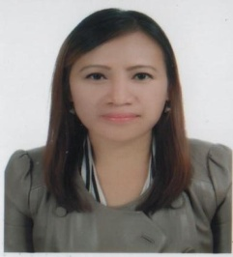

**ERMA BERNAL**

경상남도 양산시 동면 계석 3길 29 대정그린파크 아파트 1차 2동 103호

Contact no.: **010-8917-5435**

__________________________________________________________________

***WORK EXPERIENCE***

**비타민 지역 아동센터**

**March 5, 2012 – Dec. 24, 2012**

**(English Teacher)**

**Schunk Company (Yangsan City)**

**Part time English Instructor to employees**

**May, 2012 – October, 2012**

**JOB DESCRIPTION:**

* English teacher to elementary/primary students from 1st grade to 6th grade. Prepares lesson plan and other teaching materials to be used in the class.
* Work as part time English instructor to company employees.

***EDUCATIONAL ATTAINMENT***

Polytechnic University of the Philippines ComputerTechnology

Manila, Philippines (November, 1991)

Dr. Yanga’s Francisco Balagtas Colleges Secondary Level

March, 1988

Balagtas Central Elem. School Primary Level

March, 1984

***SKILLS:*** Computer literate (such as MS Word, Excel, Internet surfing), fast in typing, Encoding, Arranging files, knowledgeable in office correspondence. ***Very knowledgeable in English communication***.

***SEMINARS ATTENDED***

Conducted by:

**영산대학교 총장 부구욱 영어 원어민강사 양성과정**

**(창원 문성대학 – 창원시) September – November, 2011**

***PERSONAL INFORMATION***

Born on January 8, 1971 at San Miguel Catanduanes, Philippines, married to Mr. Jaesu Yeon and presently residing at Yangsan City, I could speak English fluently and Korean.

I have various skills that will surely help me with the job I am applying for, I am trainable and can work under pressure and this makes me confident that I could be of material assistance to you.

***ERMA BERNAL/ 베르날 이르마***